**Story telling/analysis of countries more affected with terrorism attack and recommendation system for international aide based on impact and occurrence of terrorist attack.**

If you’re a big fan of action movies, especially those on crime and the law, you’ll be familiar with the famous 9/11 attack. You may not know the details of it, but there’s this shiver of remorse that you feel each time someone refers to it. You know that it was in the U. S. and that many people died, but have you ever wondered: is it truly the most deadly act of terrorism globally? Let’s see what data has to say about that.

Our dataset on global terrorism covers 47 years of deaths across 205 countries and 12 regions. Analysis show that 2014 recorded the highest cases of terrorism with over 160000 reported and recorded. Also, of all 205 countries, Iraq, Pakistan, Afghanistan, India, Columbia, Philippines, Peru, El Savador, the United Kingdom, and Turkey, have suffered more terror than others over the recorded years.

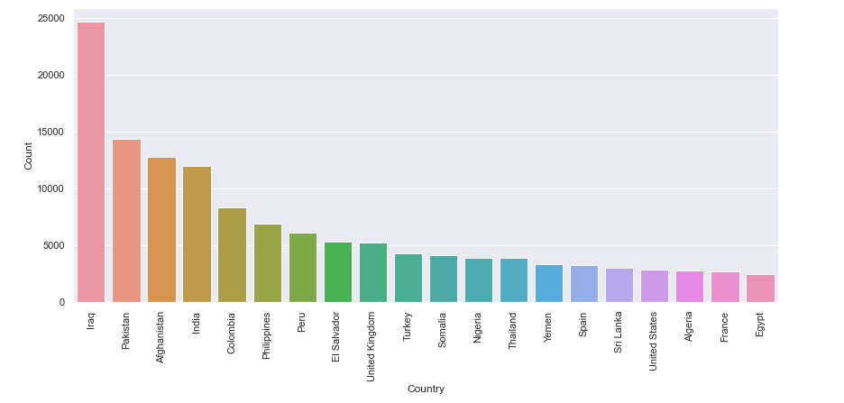

**Figure 1: Top 20 countries with the highest terror attacks**

There have been many different approaches to spreading terror nations, with bombing or explosions as the most common and destructive. It puts a target on many more people than the intended targets. Regardless of attack type or deployed weapons, these terrorists have recorded 89% success in their schemes and countries in the Middle East and North Africa bear most of the brunt of these acts.

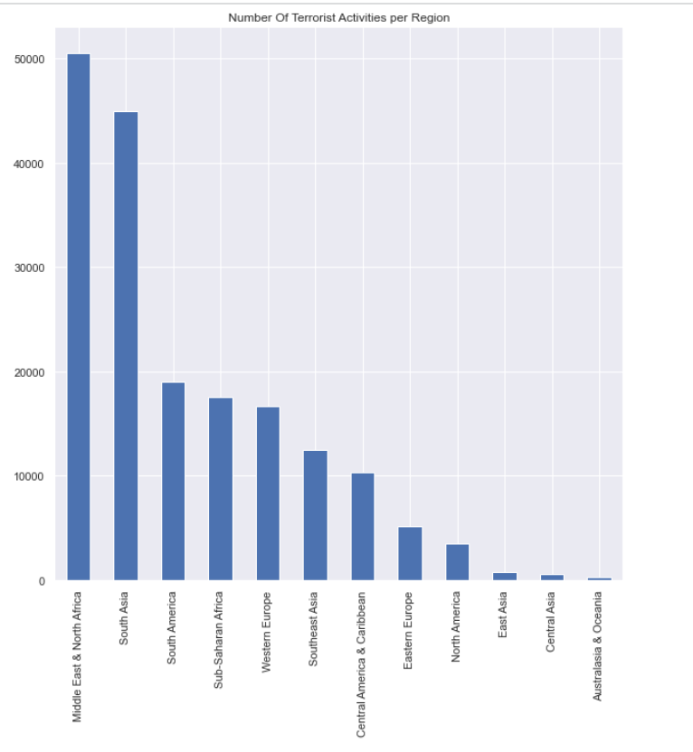

**Figure 2: Number of terrorist attacks by region**

To recommend an effective system for international aid, we must also understand the nature of the attack groups in terms of frequency and resilience. This data reports a whopping 3537 groups that have chosen to terrorise the globe. The following figure shows that the Taliban attack groups are responsible for most of the terror we’ve heard of.

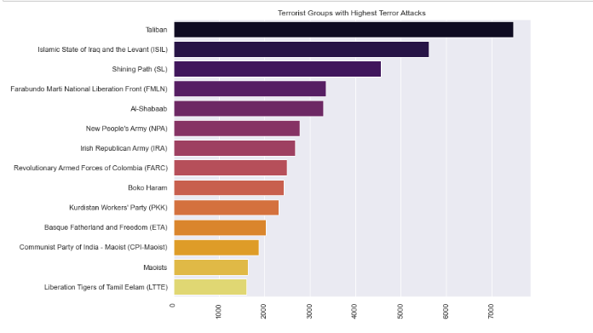

**Figure 3: Terrorist groups with the highest record of terror attacks**

The next figure shows the trends of attack over the years. You’ll notice that the Taliban group only rose after the year 2000 and have been consistent ever since. Yet, the Islamic State of Iraq and the Levant (ISIL) began exactly around 2000 and as of 2014, was causing the most damage to nations, followed closely by the Taliban, Al-Sahabaab, Boko Haram, and New People’s Army (NPA).

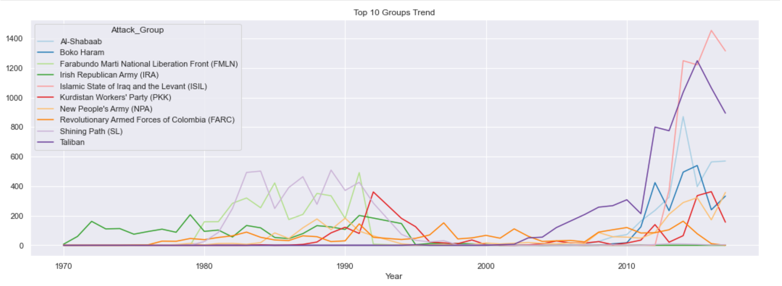

**Figure 4: Yearly trend of attack of the top 10 terrorist group around the globe**

**Recommendation for international aid**

In many cases, prevention is better than cure. Imagine having the resources to identify terrorism intent, potential targets, or even possible motives. That would go a long way in avoiding the act itself and trying to manage the outcomes.

It is therefore our recommendation that to prevent further loss of lives in *at-risk* countries and the globe in general, international cooperation and information sharing should be taken seriously. It takes more than a local attack group to blow up properties and people. Security measures for monitoring weapon movement would go a long way.

Also, all nations should be ready for the worst attacks such that there are refugee camps with enough resources to sustain survivors, tend to their wounds, and subsequently, transport them to places of greener pastures. Whatever the case, health and medical care should be the priority, and an open line of communication between all figures of authorities involved will make it possible.

Finally, terrorism doesn’t happen overnight. It takes one unpleasant event, brewing anger, and one little act of violence to things to escalate. If there was a way to rationalize with potential attack groups and provide a solution to their grievances, terrorism may soon come to an end.